Database Systems Assignment 1

Abdul Munam Aziz
23L-3019
BCS 4F

Q1-

datetime:

- From January 1, 1753 to December 31, 9999 with an accuracy of 3.33 milliseconds.
- 8 bytes of storage required
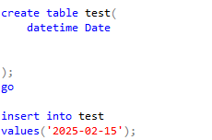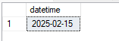

datetime2:

- From January 1, 0001 to December 31, 9999 with an accuracy of 100 nanoseconds
- 6 - 8 bytes of storage required

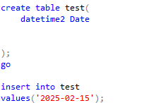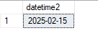

Date:

- Store a date only.
- From January 1, 0001 to December 31, 9999
- 3 bytes required

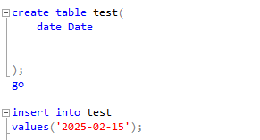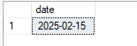

X—------------------------------------------------------------------x

Q2-

GETDATE ()
- Returns the current date and time of the system where SQL Server is running, in DATETIME format.

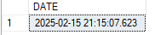

GETUTCDATE ()
- Returns the current database system UTC date and time

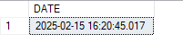

DAY ()
- Returns the day of the month for a specified date

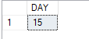

SYSDATETIME ()
- Returns the date and time of the SQL Server with higher precision

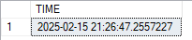

MONTH ()
- Returns the month part for a specified date (a number from 1 to 12)



ISDATE ()
- Checks an expression and returns 1 if it is a valid date, otherwise 0

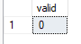

DATEPART ()
- Returns a specified part of a date (as integer)
- Can return month ,day, year as integer
- replace parameter month with day or year



DATENAME ()
- Returns a specified part of a date (as string)
- Can return month ,day, year,
- replace parameter month with day or year

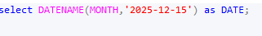
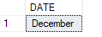

DATEDIFF ()
- Returns the difference between two dates
- Subtracts the first date parameter from the second date parameter
- Can subtract day, month and year.
- replace parameter day with year or month

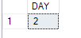

‘2025-02-15’ minus ‘2025-02-13’

DATEFROMPARTS ()
- Returns a date from the specified parts (year, month, and day values).

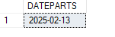

x—------------------------------------------------------------------x

Q3-

The following are the only data types for date available in sql server but using functions like CONVERT, FORMAT, and CAST dates can be shown in different formats.
- DATE - format YYYY-MM-DD
- DATETIME - format: YYYY-MM-DD HH:MI:SS
- SMALLDATETIME - format: YYYY-MM-DD HH:MI:SS
- TIMESTAMP - format: a unique number

I will be using the format function to show all available formats.

